Moving Picture, Audio and Data Coding by Artificial Intelligence
www.mpai.community

Public document
N587 | 2022/03/23
Source | General Assembly #18 (MPAI-18)
Title | MPAI workplan
Target | MPAI Community

Contents
1 Introduction 1
2 Approved standards 2
2.1 MPAI-CUI 2
3 Areas at stage 6 (SD) 2
3.1 MPAI-MMC 2
3.2 MPAI-AIF 3
3.3 MPAI-CAE 3
4 Areas at stage 2 (FR) 4
4.1 MPAI-SPG 4
4.2 MPAI-EVC 5
4.3 MPAI-CAV 6
4.4 Mixed-Reality Collaborative Spaces 6
4.5 MPAI-GSA 7
5 Areas at stage 1 (UC) 8
5.1 MPAI-OSD 8
6 Areas at stage 0 (IC) 8
6.1 MPAI-EEV 8

Introduction
MPAI’s standards development is based on projects evolving through a workflow extending on 6 + 1 stages.

# | Acr | Name | Description
0 | IC | Interest Collection | Collection and harmonisation of use cases proposed.
1 | UC | Use cases | Proposals of use cases, their description and merger of compatible use cases.
2 | FR | Functional Reqs | Identification of the functional requirements that the standard including the Use Case should satisfy.
3 | CR | Commercial Reqs | Development and approval of the framework licence of the standard.
4 | CfT | Call for Technologies | Preparation and publication of a document calling for technologies supporting the functional and commercial requirements.
5 | SD | Standard Development | Development of the standard in a specific Development Committee (DC).
6 | CC | Community Comments | When the standard has achieved sufficient maturity it is published with request for comments.
7 | MS | MPAI standard | The standard is approved by the General Assembly.

A project progresses from one stage to the next by resolution of the General Assembly.
The stages of currently (MPAI-14) active MPAI projects are graphically represented by Figure 1.
TS: Technical Specification, RS: Reference Software, CT: Conformance Testing, PA: Performance Assessment.

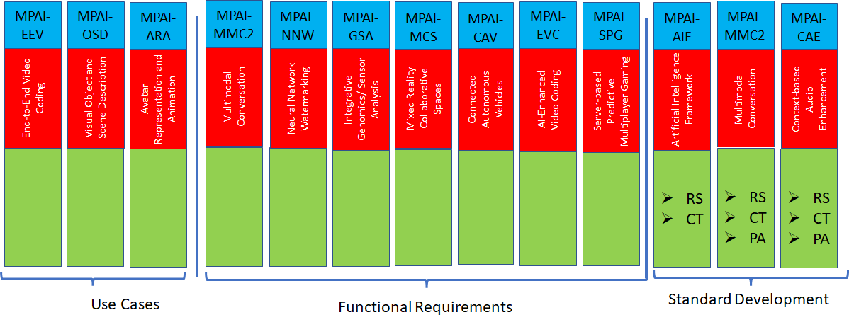
Figure 1 – Snapshot of the MPAI work plan

Approved standards

MPAI-CUI
Compression and understanding of industrial data (MPAI-CUI) aims to enable AI-based filtering and extraction of key information to predict company performance by applying Artificial Intelligence to governance, financial and risk data. This is depicted in Figure 2.
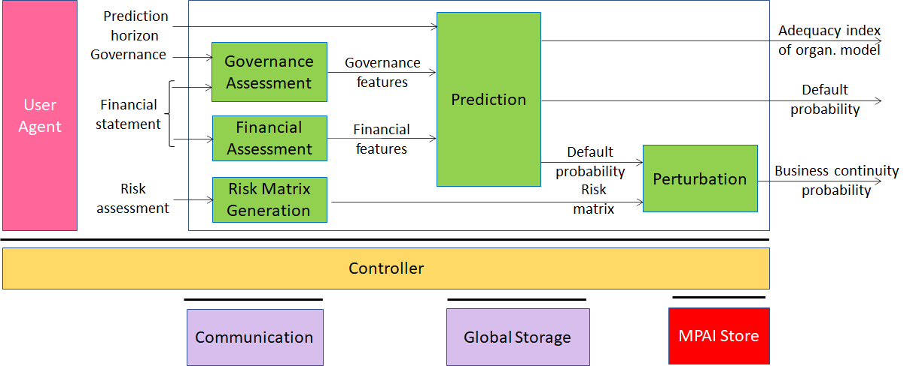
Figure 2 – The MPAI-CUI Use Case

The collection of public MPAI-CUI documents is available here. The set of specifications is available here.

Areas at stage 6 (SD)

MPAI-MMC
Multi-modal conversation (MPAI-MMC) aims to enable human-machine conversation that emulates human-human conversation in completeness and intensity by using AI.
So far, 5 Use Cases have been identified for MPAI-MMC: Conversation with emotion, Multimodal Question Answering (QA) and 3 Automatic Speech Translation Use Cases.
Figure 3 depicts the Conversation with Emotion Use Case Reference Model.

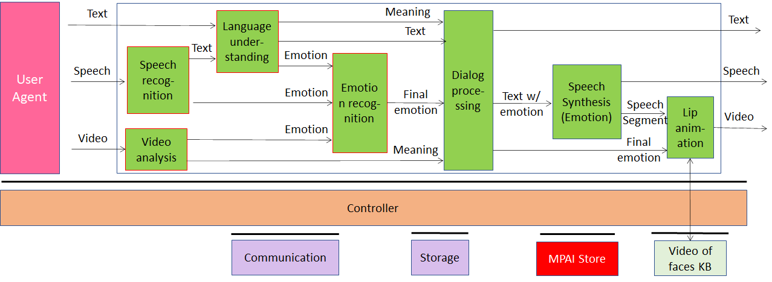
Figure 3 – An MPAI-MMC Use Case: Conversation with emotion

The collection of public documents is available here. The MPAI-MMC Technical Specification V1.1 has been approved and is available here.

MPAI-AIF
Artificial Intelligence Framework (MPAI-AIF) enables creation and automation of mixed Artificial Intelligence – Machine Learning – Data Processing workflows for the application areas currently considered by the MPAI work plan. MPAI-AIF will be extended to support new applications areas, if the need will arise. Figure 4 shows the general MPAI-AIF Reference Model.

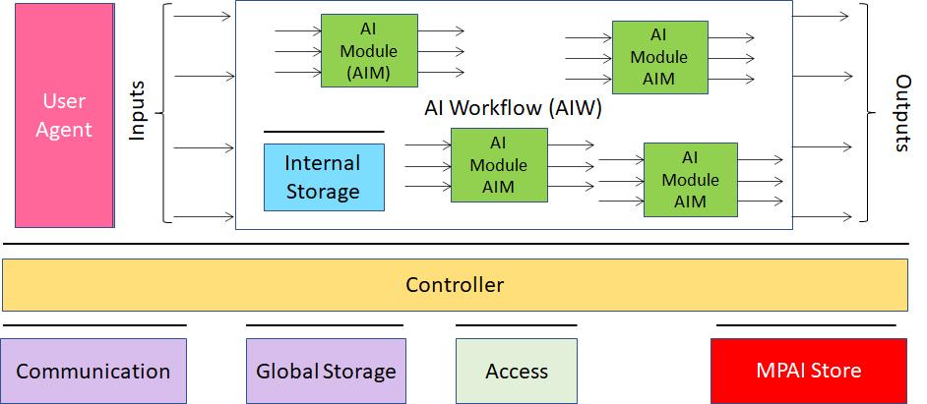
Figure 4 – Reference model of the MPAI AI Framework

The collection of public documents is available here. The MPAI-AIF Technical Specification has been approved and is available here.

MPAI-CAE
Context-based Audio Enhancement (MPAI-CAE) improves the user experience for several audio-related applications including entertainment, communication, teleconferencing, gaming, post-production, restoration etc. in a variety of contexts such as in the home, in the car, on-the-go, in the studio etc. using context information to act on the input audio content using AI.
Figure 5 is the reference model of Unidirectional Speech Translation.

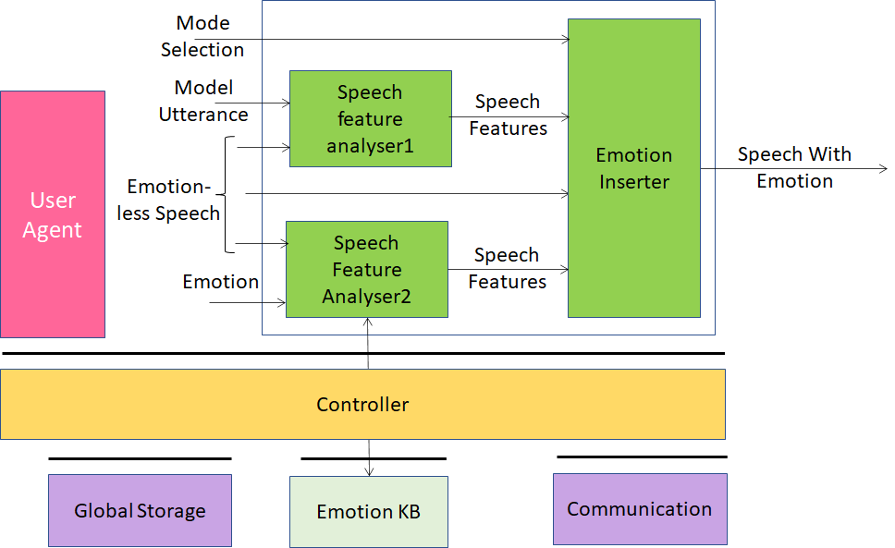
Figure 5 – An MPAI-CAE Use Case: Emotion-Enhanced Speech

The collection of public documents is available here. The MPAI-AIF Technical Specification has been approved and is available here.
MPAI has initiated work on Audio on the Go (AOG), a new use case for MPAI-CUI V2.

Areas at stage 2 (FR)

MPAI-SPG
Server-based Predictive Multiplayer Gaming (MPAI-SPG) aims to minimise the audio-visual and gameplay discontinuities caused by high latency or packet losses during an online real-time game. In case information from a client is missing, the data collected from the clients involved in a particular game are fed to an AI-based system that predicts the moves of the client whose data are missing. The same technologies provide a response to the need to detect who amongst the players is cheating.
Figure 6 depicts the MPAI-SPG reference model including the cloud gaming model.

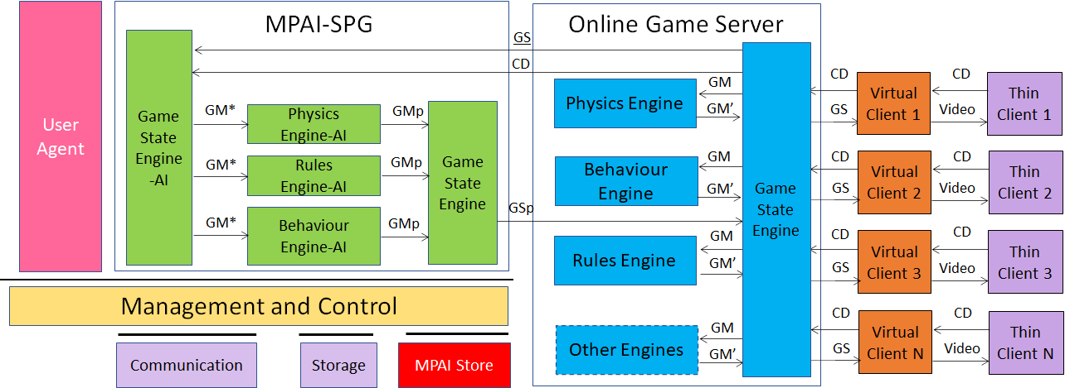
Figure 6 – The MPAI-SPG Use Case

The collection of public documents is available here.

MPAI-EVC
AI-Enhanced Video Coding (MPAI-EVC) is a video compression standard that substantially enhances the performance of a traditional video codec by improving or replacing traditional tools with AI-based tools. Two approaches – Horizontal Hybrid and Vertical Hybrid – are envisaged. The Vertical Hybrid approach envigaes an AVC/HEVC/EVC/VVC base layer plus an enhanced machine learning-based layer. This case can be represented by Figure 7.

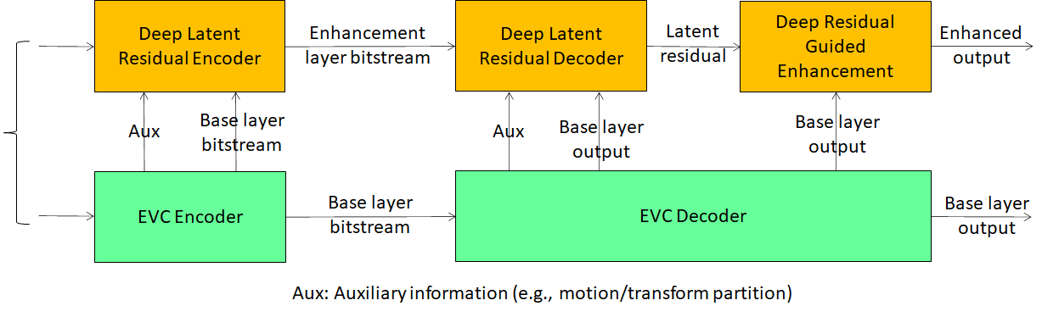
Figure 7 – A reference diagram for the Vertical Hybrid approach

The Horizontal Hybrid approach introduces AI based algorithms combined with traditional image/video codec, trying to replace one block of the traditional schema with a machine learning-based one. This case can be described by Figure 8 where green circles represent tools that can be replaced or enhanced with their AI-based equivalent.
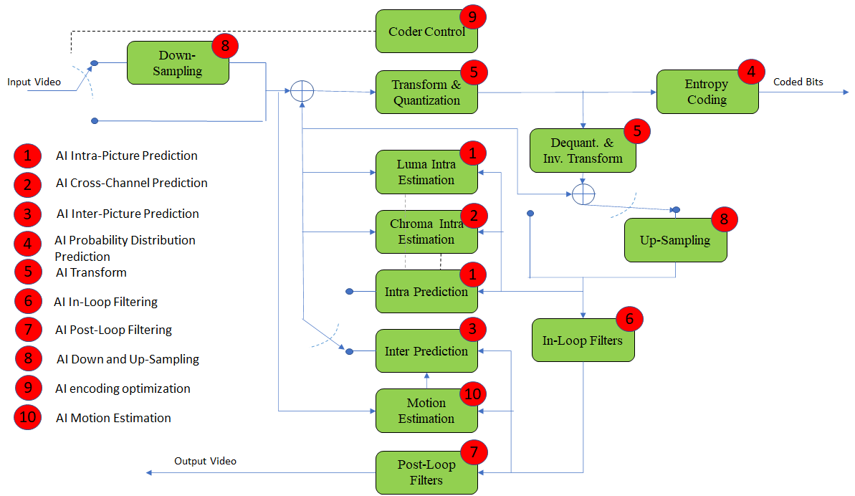
Figure 8 – A reference diagram for the Horizontal Hybrid approach

MPAI is engaged in the MPAI-EVC Evidence Project seeking to find evidence that AI-based technologies provide sufficient improvement to the Horizontal Hybrid approach. A second project on the Vertical Hybrid approach is being considered.
The collection of public documents is available here.

MPAI-CAV
Connected Autonomous Vehicles (CAV) is a Use Case addressing the Connected Autonomous Vehicle (CAV) domain and the 5 main operating instances of a CAV:
- Human-CAV interaction (HCI), i.e., the CAV subsystem that responds to humans’ commands and queries, senses human activities in the CAV passenger compartment and activates other subsystems as required by humans or as deemed necessary by the identified conditions.
- CAV-Environment interaction, i.e., the subsystem that acquires information from the physical environment via a variety of sensors.
- Autonomous Motion Subsystem (AMS), i.e., the CAV subsystem that uses different sources of information to instructs the CAV to reach the intended destination.
- CAV-Device Interaction (CDI), i.e., the subsystem that communicates with sources of external information, including other CAVs, Roadside Units (RSU), other vehicles etc.
- Motion Actuation Subsystem (MAS), i.e., the subsystem that operates and actuates the motion instructions in the physical world.
The interaction of the 5 subsystems in depicted in Figure 9
Figure 9 – The CAV subsystems

The collection of public documents is available here.

Mixed-Reality Collaborative Spaces
New technologies are emerging which equip developers to deliver mixed-reality collaborative space (MCS) scenarios where biomedical, scientific, and industrial sensor streams and recordings are to be viewed. Artificial Intelligence can be utilized throughout MCS systems for immersive presence, spatial maps (e.g. Lidar scans, inside-out tracking) rendering, and multiuser synchronisation etc.
Figure 10 depicts one Use Case being considered: “Virtual e-learning”

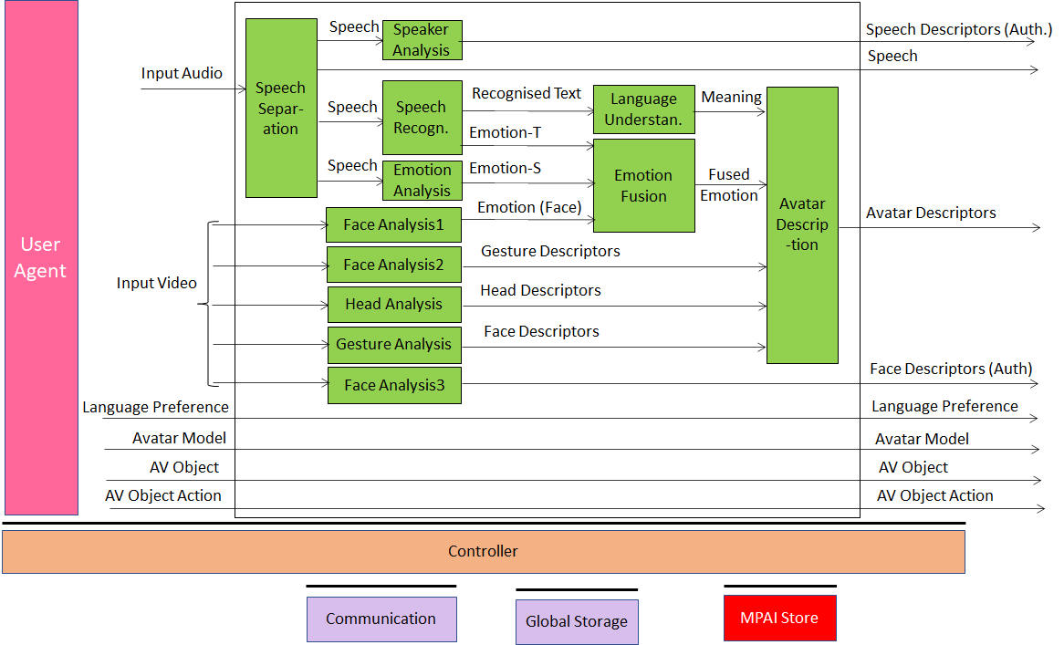
Figure 10 – The Client Based Ambient Reference Model (Client TX)

The collection of public documents is available here.

MPAI-GSA
Integrative Genomic/Sensor Analysis (MPAI-GSA) uses AI to understand and compress the result of high-throughput experiments combining genomic/proteomic and other data, e.g., from video, motion, location, weather, medical sensors.
Figure 11 addresses the Smart Farming Use Case.

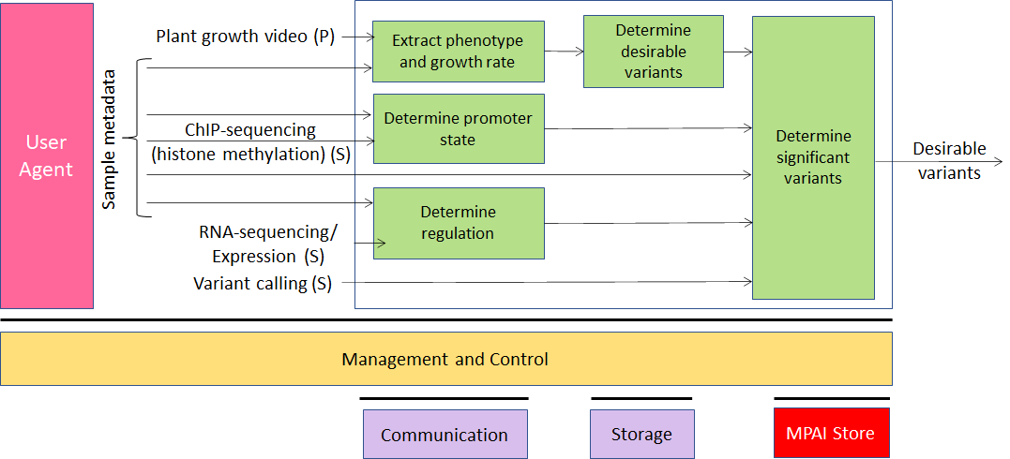
Figure 11 – An MPAI-GSA Use Case: Smart Framing

The collection of public documents is available here.

MPAI-MMC V2
Multi-modal conversation V2 (MPAI-MMC V2) aims to enable human-machine conversation that emulates human-human conversation in completeness and intensity by using AI.
So far, 3 new Use Cases have been identified: Conversation About a Scene (CAS), Human-CAV Interaction (HCI) and Avatar-Based Videoconference (ABV).

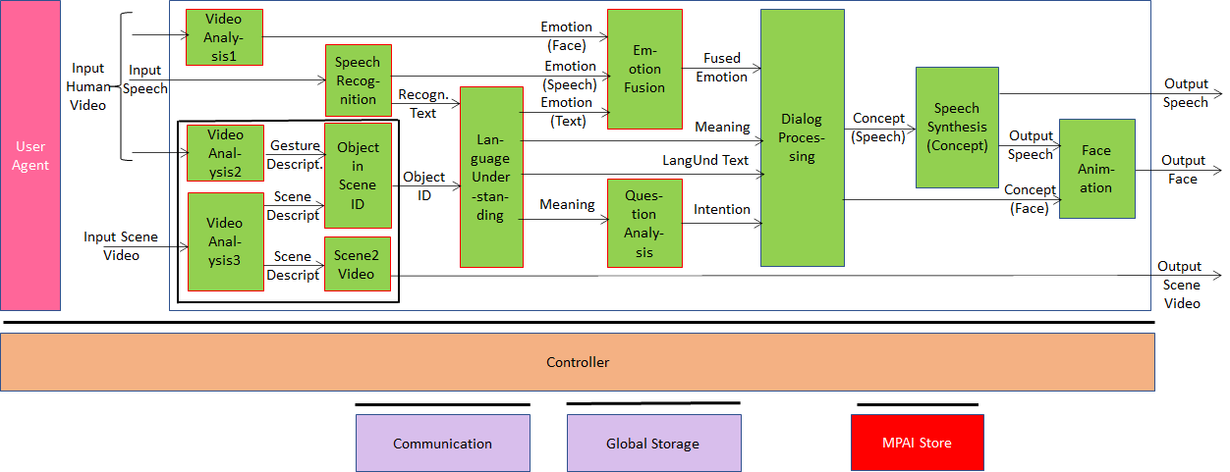
Figure 3 – An MPAI-MMC Use Case: Conversation with emotion

Areas at stage 1 (UC)

MPAI-ARA
Avatar Representation and Animation (ARA) is a project developing requirements for standards supporting the needs of MPAI-MMC, MPAI-CAV and MPAI-MCS.

MPAI-EEV
There is consensus in the video coding research community that the so-called End-to-End (E2E) video coding schemes can yield significantly higher performance than those target, e.g., by MPAI-EVC. AI-based End-to-End Video Coding intends to address this promising area.
The collection of public documents is available here.

MPAI-NNW
Neural Network Watermarking is a project developing requirements for a standard enabling the measure, for a given size of the watermarking payload, of:
- The impact, e.g., the degradation of the user experience caused by the watermark applied to a neural network.
- The resistance to attacks, e.g., transfer learning, pruning.
- The processing cost of watermarking injection, e.g., time, processing cost.

MPAI-OSD
Visual object and scene description is a collection of Use Cases sharing the goal of describe visual object and locate them in the space. Scene description includes the usual description of objects and their attributes in a scene and the semantic description of the objects.
Unlike proprietary solutions that address the needs of the use cases but lack interoperability or force all users to adopt a single technology or application, a standard representation of the objects in a scene allows for better satisfaction of the requirements.
The collection of public documents is available here.

Areas at stage 0 (IC)

