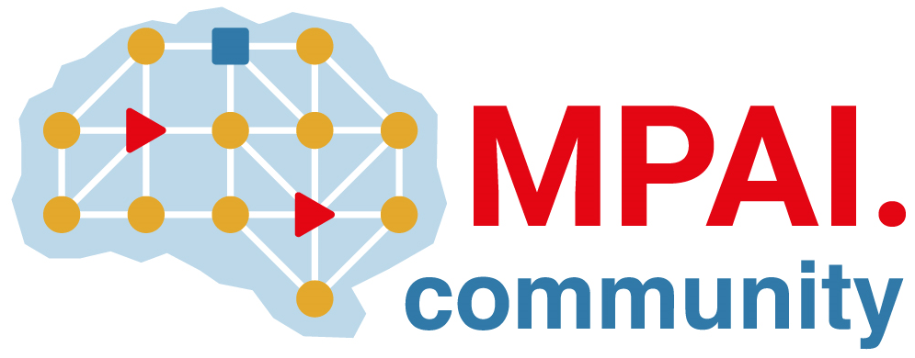 | Moving Picture, Audio and Data Coding  by Artificial Intelligence  www.mpai.community

 | Public document
N603 | 2022/03/23
Source | Requirements (CAV)
Title | MPAI-CAV Progress report and plans
Target | MPAI-18

The current activities of Requirements are divided into two parts:
- The Human-CAV Interaction Subsystem, whose activities, with the exclusion of the Full World Representation viewing and control, have been transferred to MMC-DC and Requirements (ARA).
- The Environment Sensing, Autonomous Motion and Motion Actuation Subsystems whose activities are progressing.

The group has submitted the paper Human interaction with Connected Autonomous Vehicles to MetroCAD22

