Moving Picture, Audio and Data Coding by Artificial Intelligence
www.mpai.community

N653 | 2022/04/20
Source | Requirements (MCS)
Title | XR Theatre Use Case – Model and components
Target | MPAI Community

Introduction
Figure 1 depicts the XR Theatre Use Case and its components.

Figure 1 – Reference Model of the XR Theatre Use Case
The XR Theatre components perform the following functions:
- Real World is where humans, in all their functions (Video Jockey, Performers and humans belonging to the Audience) are located.
- Feature Extraction extracts basic elements, e.g., Performer’s gesture.
- Feature Interpretation extracts the semantics of feature, e.g., thumbs up.
- Action Generation converts interpreted features into actionable instructions, e.g., turn on the lights.
- Virtual World is the place mixing synthetic assets and projections of the Real World.
- Experience Generation converts instructions into encoded data (bits).
- Real World Delivery converts bits representing virtual objects into signals – visual, auditory, tactile, smell, taste perceivable by humans.

The Real-to-Virtual line
Figure 2 depicts the Real-to-Virtual processing line of Figure 1.

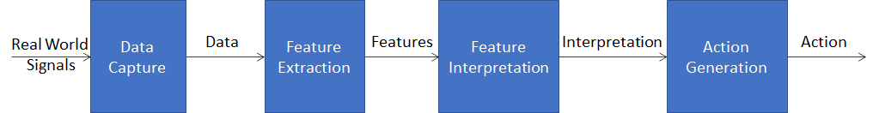
Figure 2 - The Real-to-Virtual line
The scope of the 4 steps is not uniquely and universally defined. There should be no doubt that PCM Video is the output of Data Capture, but is video compression part of Data Capture? Possibly, DPCM-coded video is, but sophisticated motion-compensation video compression should probably be part of Feature Extraction.

Examples are:
- In a human-machine conversation, the machine has asked “should I go?”. The machine captures the video of the head of the human and interprets that the human is nodding. The machine realises that nodding (e.g., in conjunction with a speech-based dialogue) means that it should go and executes.

Human face – Face feature extraction – Face feature interpretation – Action (Go)

- A human controls the cursor on a screen wearing an EEG cap. The machine extracts EEG features, then interprets the EEG features and understands that the human is thinking of moving the cursor up. The machine executes.

Signals from EEG – EEG feature extraction – EEG feature interpretation – Action (cursor up)

Including the metaverse
In a metaverse environment, raw data, i.e., the data captured by sensors, can be enter the metaverse directly or after pre-processing, i.e., after feature extraction or after feature interpretation or after action. Therefore. there are different configurations depending on where a particular function is, in the machine or in the metaverse:
- The machine is an integral part of the metaverse receiving sensor data directly.
- The machine is partly outside of the metaverse effecting only certain one of the following functions on raw data:
  - Hands over features to the metaverse.
  - Hands over interpreted features to the metaverse.
  - Hands over action to the metaverse.
In the two examples above, if the machine is fully part of the metaverse, it receives the video of the human face or the EEG signals. Otherwise, it extracts the features from the raw data leaving their interpretation to the metaverse, or it interprets features leaving the conversion of features into action to the metaverse, or it converts the interpreted features into action and passes it to the metaverse.
This is depicted in Figure 3.

Figure 3 - The 3 data processing stages in the Real-ot-Virtual line
Note that Interpretation can be culture-dependent and Action can be application-dependent.

The Virtual-to-Real line
In some cases, there is no metaverse, but Experience Generation devices taking actions and producing data structures representing “Digital Experiences” that humans can perceive by if they use Experience Delivery devices. Experience Generation devices can be considered as “downsized metaverses”. Therefore, the input/output data formats of an Experience Generation device should be the same as the input/output data formats of a metaverse.

Data in the XR Theatre Use Case
Figure 4 gives a comprehensive view of the devices and data relevant to the XR Theatre Use Case.

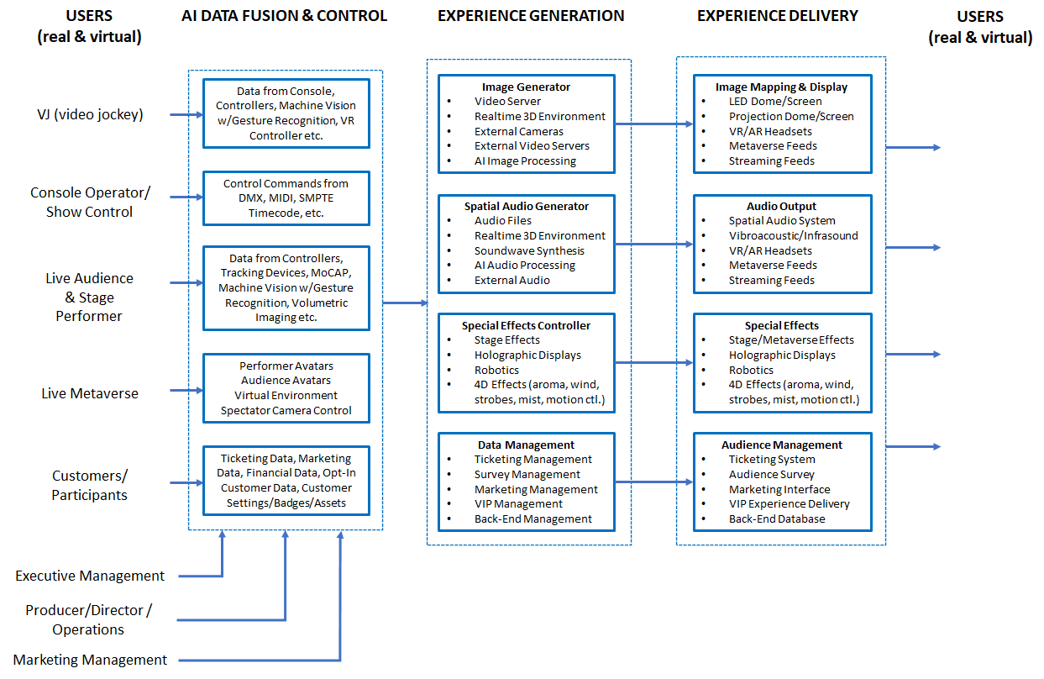
Figure 4 - Devices and data of the XR Theatre Use Case
Table 1 analyses the data generated by the left-hand side of Figure 4 using the 4 stages of data processing identified in Figure 2.
Data is generated by humans in different instances:
- Video Jockey
- Performer
- Audience

Table 1 - Data from the Real World
Data types | Raw data | Features | Interpretation | Action
Audio | Mono, stereo, multichannel | Audio scene description
 |  | Frequency analysis
Speech |  | Speech scene | Text (ASCII) | Translation
 |  |  | Emotion
 |  |  | Intent
 |  |  | Meaning
Video | Generic video scene | Video scene description
 |  | Objects or body | Bodyàs skeleton
 |  | Objects’ position-orientation & derivatives
 | Entire body | Objects’ position-orientation & derivatives |  | Avatar Animation
 | Torso
 | Gesture | Keypoints | Sign language | Avatar Animation
 | Face |  | Identification
 |  | FACS | Expression | Avatar Animation
 | Eye | Eye tracking | Viewer’s interest
Body sensors | Raw data from sensors (positional, 3DoF-6DoF) | Relative position and orientation of body parts - Skeleton | Interpreted gestures  What the skeleton does expressed in a (choreography) language | Avatar Animation
Biometric | EEG waveforms |  | Thought
 | Heart rate over a period of time beats/min | Heart rate variability | Excitation, anger, pleasure
Manual control | Button | on-off | (context-dependent)
 | Joystick | x-y-z values | (context-dependent)
 | Camera control | PoV x’-y’-z’ values  FoV angle, Interocular separation and orientation cm and angle | Interpretation of the operator’s intention when capturing the scene
 | Controller

Table 2 analyses the data going to the left-hand side of Figure 4.
Data consumed by humans come from the Metaverse or from the Experience Generator.

Table 2 - Data to the Real World
Data types
Audio | Natural or synthetic sound
Speech | Natural or synthetic speech
Full MV visual experience
Haptics | Force feedback
 | touch
 | vibration
 | haptic
 | vest
 | glove
Vestibular feedback | 6DoF motion platform

Earlier notes
Scope of the use case
- Capture, processing, interpretation and action of actors (audience, performer and VJ) data:
  - Audience interactivity
    - Capturing the “sentiment”, “behaviour”, “mood”, “intent” (in the following called “sentiment etc.”) of an audience (common or individual, average, variance) including behaviour (gestures, facial), biometric (e.g., heart rate, brainwaves), audiometer (cheering, booing), buttons and controllers at the seats. It is called “Reading the room”. One solution is supervised learning of a machine by feeding it with many instances of labelled “common” sentiments. There is also the possibility of unsupervised learning. If we do it, we would need to define the type of signals that we use to measure the “sentiment, etc.” to train the machine and the human-recognisable categories of “sentiment etc.” and exactly what “sentiment etc.” means. “Sentiment etc.” is dependent on culture. Compared to capturing the “sentiment etc.” of an individual done in MPAI-MMC, here we are measuring the sentiment of a crowd.
    - Measuring the “response”, “affect”, caused by a known stimulus. This is a system-level problem. We present something that influences a crowd and may influence what is being presented. The result may be adapting the multisensory (e.g., visual audio, aroma, haptic, vibration, fog, special effects, performer’s movement) stimulus based on the sentiment etc. captured.
  - Performer’s interactivity.
    - Gesture recognition and interpretation of the “meaning” of a performer’s movement, e.g., sign language, dance notation, mudras language are examples of how a stimulus can be captured and interpreted. A machine could be trained with labelled performer movement for the required instances of cultures and contexts.
    - The trained machine would provide the interpreted gestures. Another machine can be trained to adapt the multisensory stimulus based on the interpreted gesture.
  - VJ interactivity
    - Gesture capture, recognition and interpretation of the “meaning” of VJ movements and, gestures. A machine could be trained with labelled performer movement for the required instances of cultures and contexts.
    - Another machine receives the interpreted gestures and is trained to adapt the multisensory stimulus based on the interpreted gesture.
- Raw data interface to/from the Metaverse. The MV exists with its own platform and its two-way interface (viewing, controlling and receiving a reaction from the MV). User’s multisensory experience (input and output) can include:
  - Audio, may be the result of pre-processing to get the intended audio
    - in: speech, my music, spatial audio field;
    - out: sound from the MV
  - Visual, may be the result of pre-processing to get the intended visual info
    - in: my face, my entire body;
    - out: the entire visual experience of a MV room from the PoV of the avatar; interocular separation, foveation
  - Gesture
    - in: kinetic tracking of physical body parts;
    - out: force feedback from a robot, a subset of haptics
  - Position, acceleration
    - in: coordinates+derivative, orientation+derivative in the user’s space
  - Vestibular feedback
    - out: 6DoF motion platform
  - Haptic (out: touch, vibration, haptic vest, glove)
  - Manual controls (in: e.g., buttons, joysticks)
  - Biometric (in: e.g., eye tracking, EEG, EOG)
  - Headset (in/out: some of the above features in an integrated fashion)
  - Spectator camera control. A “camera operator” is provided specialised control to select and animate (e.g., by walking in the metaverse) the PoV of a virtual scene to broadcasts the corresponding scene.
    - in: e.g., camera control parameters, position, orientation, field of view.
    - out: audio-visual.
- Processing of the raw data to act on the metaverse in a variety of ways:
  - Interpretation of the data by extracting information such as
    - Emotion, e.g., speech intonation, facial expression
    - Non-verbal communication, face (nod, wink etc), sign language
    - Intent
    - Meaning
  - Action following interpretation
    - Manipulation of avatars
    - Modification of virtual environment
- Multichannel audio environment management. Multiple audio sources from geographically separated places send their audio through the internet. How to combine the sound signals in such a way that synchronisation with universal time is preserved with an accuracy of 10 ms (to achieve musicality as opposed to a real-time conversation between two remote people).

