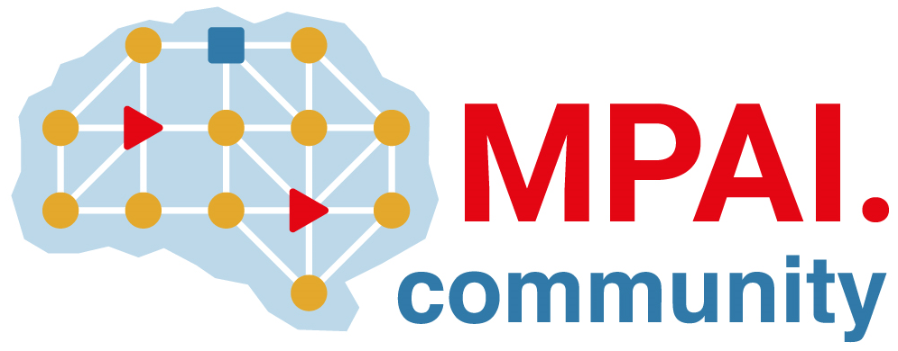 | Moving Picture, Audio and Data Coding  by Artificial Intelligence  www.mpai.community

 | Public document
N655 | 22/04/20
Source | Requirement (NNW)
Title | Progress report and plans
Target | MPAI Community

This month, MPAI-NNW has worked on two directions, use cases and functional requirements, that are developed inside a unique document.
Minor updates have been done on the use cases part: editing, advanced explanations, more detailed visuals.
In order to identify the proper requirements, consequent efforts have been made on identifying the scope of the MPAI NNW standard: “The purpose of the MPAI Neural Network Watermarking (NNW) standard is to enable watermarking technology providers to qualify their products”, as detailed in N653.
Now that the three “support” documents are completed (state-of-the art, project presentation, use cases and scope of the standard), it is important to finalize the requirements to define what is standard for this project. In parallel, it is important for us to get more involved in the MPAI effort, e.g. MPAI-AIF, MPAI marketplace, …

